Mamadu Bah
Dr. Bemley
CTEC 298
Matplotlib Plots
Plots
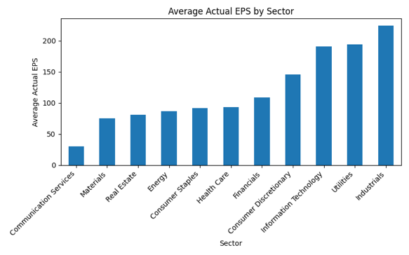

This bar chart compares the average Actual EPS for companies across different sectors. It shows which industries performed stronger financially based on real earnings, not estimates. Sectors with taller bars had better profitability, while sectors with lower values underperformed. This helps identify which areas of the market delivered the most earnings in this dataset.
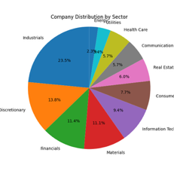
This pie chart displays how many companies in the dataset belong to each sector. By showing the percentage breakdown, we can quickly see which industries are most represented. A sector with a larger slice of the pie has more companies contributing to the earnings data, which may influence overall trends and averages in the dataset.
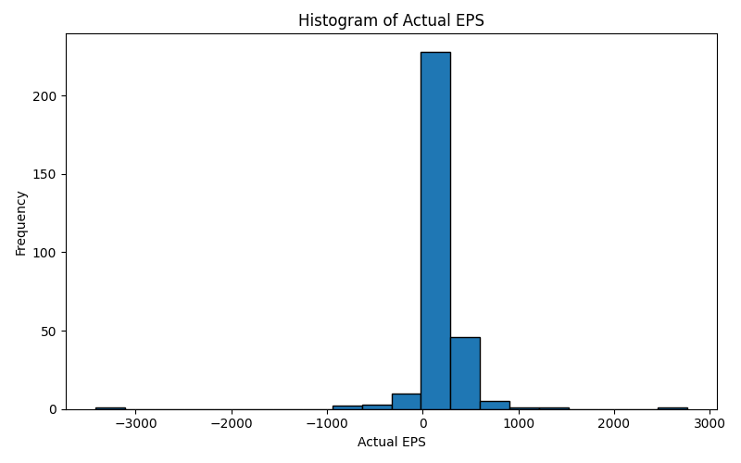
This histogram shows how Actual EPS values are spread across all companies in the dataset. We can see whether most companies earned low, moderate, or high EPS amounts. If the bars cluster on one side, it indicates that most companies fall into a similar performance level. This visualization helps identify outliers and overall consistency in company earnings.
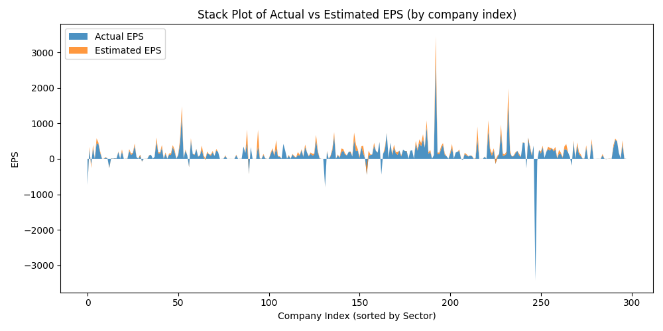
The stack plot shows how Actual and Estimated EPS add up across all companies in the dataset. It allows us to visualize the total earnings being contributed from each category. If the Actual EPS section consistently rises above the Estimated EPS, that means real performance was stronger than predictions across the dataset. This gives a big-picture view of estimates versus reality.
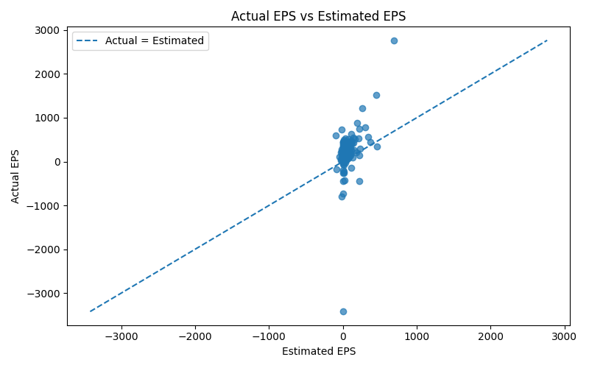
The scatter plot compares actual performance with projections. Each dot represents a company. If a dot sits above the diagonal reference line (if shown), it means the company performed better than estimated. If it falls below, the company underperforms. This helps reveal whether companies tended to exceed expectations or fall short overall.
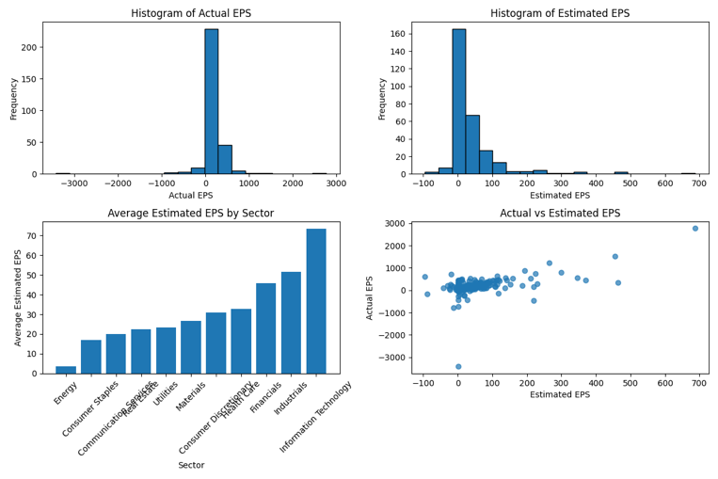
The multiplot figure places different chart types side-by-side to summarize multiple insights at once. For example, one panel might show distributions, another may compare sectors, and another may show the relationship between estimates and actuals. When viewed together, these visuals help confirm whether the same patterns appear across different types of charts, making the data analysis more convincing and easier to explain.
Code
